**Skema Markah Mock Test 2**

**Matematik Tambahan Kertas 2**

**Bahagian A**

**1**  [1]

 [1]





 [1]

 ,  [1]

,  [1]

 [1]

**2** (a)  [1]

*r* = 2 cm [1]

(b) $a=64, r=\frac{1}{4}$ [1]

$S_{∞}=\frac{64}{1-\frac{1}{4}}$ [1]

$=85\frac{1}{3}$ [1]

**3** (a) $3x-2=-x+2$ [1]

$x=1 , y=1$

$P(1, 1)$ [1]

(b) (i) *RQ = RP* [1]

$\sqrt{{\left(x-2\right)}^{2}+{(y-2)}^{2}}=\sqrt{y^{2}}$ [1]

$x^{2}-4x-4y+8=0$ [1]

(ii) Show by solving simultaneous equations

$x^{2}-4x-4\left(-x+2\right)+8=0$ [1]

*x*= 0 ( only one point of intersection) [1]

Therefore the line $y=-x+2$ is a tangent.

**4** (a) cos 4*x* = cos [2(2*x*)] = cos2 2*x* − sin2 2*x* [1]

= cos22*x* ( 1 − ) [1]

= cos22*x* ( 1 − tan2 2*x*) [1]

(b)

*y*

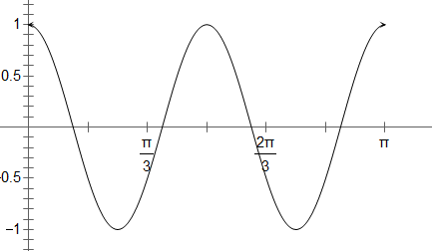

*x*

*y = k*

* Cosine Shape with correct amplitude = 1 [1]
* 2 cyles within the domain [1]
* Draw line y = −1 [1]
* k = −1 [1]

**5** (a) $y=a^{3}$ [1]

${\left(y\right)}^{\frac{1}{6}}={(a^{3})}^{\frac{1}{6}}$ [1]

$\sqrt{a}=y^{\frac{1}{6}}$ [1]

(b) $\log_{a}\left(\frac{y^{3}}{a^{2}}\right)=\log_{a}y^{3}-\log_{a}a^{2}$ [1]

$=3\log_{a}y-2\log_{a}a$ [1]

$=3\left(3\right)-2$ [1]

$=7$ [1]

**6** (a) $m=30.5+\left(\frac{\frac{75+k}{2} - 35}{30}\right)×10=35.5$ [1][1]

$\frac{75+k}{30}-35=15$

$k=25$ [1]

(b)  [1] [1]

= 173.79 [1]

(c) (i) median = 41.5 g [1]

(ii) 173.79 [1]

**Bahagian B**

|  |  |  |  |  |  |  |  |
| --- | --- | --- | --- | --- | --- | --- | --- |
| *x* | 10 | 20 | 25 | 40 | 50 | 60 | 70 |
| $$\frac{y}{x}$$ | 1.30 | 2.55 | $$\frac{p}{25}$$ | 5.00 | 6.25 | 7.30 | 8.60 |

**7**  (a)

[1] *Ignore $\frac{p}{25}$

*c =0.1*

*m=0.1214*

$$\frac{y}{x}$$

*x*

*O*

(b)

At least 1 point correctly plotted . [1]

All points correctly plotted. [1]

Best fit line [1]

* Ignore (25, $\frac{p}{25}$)

(c) (i) $\frac{y}{25}=3.1$ [1]

*k* = 77.5 [1]

(ii) $\frac{y}{x}=\frac{1}{a}+\frac{b}{a}x$ [1]

*a* =10 [1]

(iii) $\frac{b}{a}=0.1214$ [1]

*b* = 1.214 [1]

**8** (a) (i) $\frac{dy}{dx}=2x-6$

$y=x^{2}-6x+c$ [1]

0 = ${(4)}^{2}-6(4)+c$

c = 8

$y=x^{2}-6x+8$ [1]

(ii) 3 = 2(*h*) +1

*h* = 1 [1]

(iii) Area = $\int_{0}^{1}{x^{2}-6x+8} dx-\int_{0}^{1}{2x+1} dx$ [1]

= ${\left[\frac{x^{3}}{3}-3x^{2}+8x\right]}_{0}^{1}- {\left[x^{2}+x\right]}_{0}^{1}$ [1]

= $5\frac{1}{3}-2$

= $\frac{10}{3}$ [1]

(b) $π\int_{0}^{k}{4-y} dy=6π$ [1]

$π{\left[4y-\frac{y^{2}}{2}\right]}_{0}^{k}=6π$ [1][1]

$4k-\frac{k^{2}}{2}=6$

$k^{2}-8k+12=0$

$k=6, k=2$

*k* = 2 [1]

**9** (a) (i) – *u* + 4 *v* [1]

(ii) $\vec{MP}=-2$*v* +3*u* [1]

$\frac{1}{5}$ (– 2*v* + 3 *u*) or $\frac{3}{5}$*u $-\frac{2}{5}$* *v* [1]

(iii) 2 *u* + $\frac{4}{5}$ ( –3*u* + 2*v*) or – *u* + 2*v* + $\frac{3}{5}$*u $-\frac{2}{5}$* *v* [1]

$-\frac{2}{5}$*u* + $\frac{8}{5}$*v* [1]

(b) $\vec{TQ}$ = $-\frac{3}{5}$*u* + $\frac{12}{5}$*v* [1]

$\vec{RT}$ = $-\frac{2}{5}$*u* + $\frac{8}{5}$*v*

*= 2 $(-\frac{1}{5}$* *u* + $\frac{4}{5}$*v* )

= $\frac{2}{3}$ ( $-\frac{3}{5}$*u* + $\frac{12}{5}$*v* )

$\vec{RT}=\frac{2}{3} \vec{TQ}$ [1]

$\frac{RT}{TQ}=\frac{2}{3}$

RT : TQ = 2 : 3 [1]

(c) 🡺

Area of PQT = $\frac{4}{5}×25$ [1]

= 20 [1]

**10** (a) (i) $P\left(x≥2\right)=1-P\left(x=1\right)-P\left(x=0\right)$

$=1-{{}_{}^{5}C}_{1}{\left(\frac{1}{3}\right)}^{1}{\left(\frac{2}{3}\right)}^{4}- {{}_{}^{5}C}_{0}{\left(\frac{1}{3}\right)}^{0}{\left(\frac{2}{3}\right)}^{5}$ [1]

= $\frac{131}{243}$ atau 0.5391 [1]

(ii) $μ=19 ,$ [1]

$σ=3.559$ [1]

(b) (i) $P\left(x>3.75\right)$

= $P\left(z>\frac{3.75-3.672}{\sqrt{0.2704}}\right)$ [1]

= $P\left(z>0.15\right)$

= 0.4404 [1]

(ii) $P\left(3.0<x<3.75\right)$

= $P\left(\frac{3.0-3.672}{\sqrt{0.2704}}<x<\frac{3.75-3.672}{\sqrt{0.2704}}\right)$ [1]

= $P\left(-1.292<z<0.15\right)$

= 1 – 0.4404 – 0.0981 [1]

= 0.4615 [1]

= 46.15 % [1]

**11** (a) sin(½∠*COD*) = 5/8 [1]

½∠*COD* = 0.675 rad.

∠*COD* = 1.350 rad. [1]

(b) ∠*XAD =*∠*XBC* = π/2+0.675 = 2.246 rad. [1]

Length of arc CD or arc CX or arc DX [1]

Perimeter = 13(1.350) + 2 x 5 x 2.246 [1]

= 40.01 cm [1] Accept 40.0 cm

(c) Area of triangle OAB = ½(8)2sin(1.350) or 2 x ½(5)(√(82 - 52)) [1]

= 31.223 / 31.225

Area of sector OCD or Area of sector DAX or Area of sector CBX

= ½(13)2(1.350) = ½(5)2(2.246) [1]

= 114.075 cm2 = 28.075

Area of shaded region = 114.075 – 31.223 – 2(28.075) [1]

= 26.702 cm2 [1]

**Bahagian C**

**12** (a)(i) $\frac{120×30}{100}=36$ [1][1]

(ii) $\frac{140}{100}×\frac{125}{100}×100=175$ [1][1][1]

(b) (i) $\frac{2x+140\left(4\right)+120\left(3\right)+110(5)}{2+4+3+5}=120$ [1][1]

$x=105$ [1]

(ii) $120×\frac{120}{100}=144$ [1][1]

**13** (a)(i)



(ii)





(iii)

 [1]



(b)

 [1]



**1**4 (a) $I : x+y≤7000$ [1]

$II : y≤2x$ [1]

$III :y≥1000$ [1]

(b)

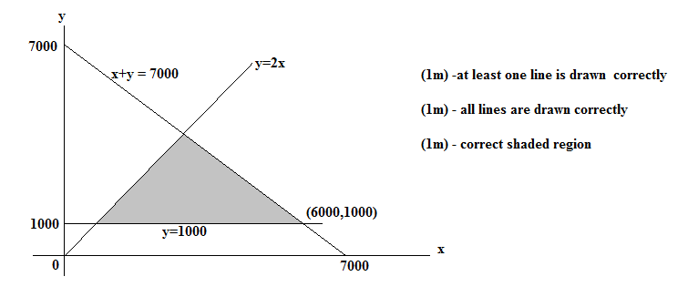

(c)(i) 5000 **  [1]

(ii) Maximum profit/ keuntungan maksimum = 50(6000) + 30(1000) [1][1]

= RM 330000 [1]

**15** (a) *a=m+nt*

*– 10 =m + n(0)*

*m = – 10*  [1]



(b)



(c)

